Configuring Portech 372 GSM Gateway for 3CX PhoneSystem
IMPORTANT This device has been tested for Voice using firmware 'PCB mark: 2N149A '.
Configuration is a 2 step process. First you configure 3CX Phone System for use with the Portech.
Step 1: Configuring 3CX PhoneSystem to work for use with the Portech MV372
- In the 3CX Management Console, click on the “Add PSTN” link in the left-hand side.
- Assign a name to this device; e.g. “Portech MV372”
- Select the Radio button labeled “Generic Gateway” and click the “Next>” button.
- The “VoIP Gateway Configuration” page will require you to insert the IP Address of the device (in this example 10.0.0.37), the port number (default is 5060), and the Number of ports.
- The “Add VoIP Lines: Create Lines” page will appear and the necessary fields will be pre-populated with suggested values. You may customise these values for your requirements, even though the default values suggested should work well. In particular, the “Identification” field may be set to the number of the line provided by the telephone company for that line. Click on the “Next ” button.
- The “Create Outbound Rule” page will allow you to quickly create a rule with which to deliver calls through this device. Specify a prefix for the rule to identify outbound calls. Click on the “Finish” button when ready, or click on the “Skip” button if you do not wish to create an outbound rule for this device at this stage.
- The “Gateway Created” summary page will list the settings you will require to apply to the device.
- Repeat steps 1 to 7, however at step 4 you will need to change the port to 5062.
At this stage 3CX is set and awaiting registrations and subsequent calls to and from the Portech.
Step 2: Configuring the Portech MV372 to register and communicate with 3CX PhoneSystem
1. Connect the Portech 372 GSM gateway to the network and mains power supply. The device will boot up, using its factory-configured default IP address 192.168.0.100.
2. Now point your browser to the gateway’s configuration site: http://192.168.0.100
3. Enter the Username and password of the device and click ‘OK’ to access the gateway’s configuration. The default Username is “voip” and the password is “1234”.
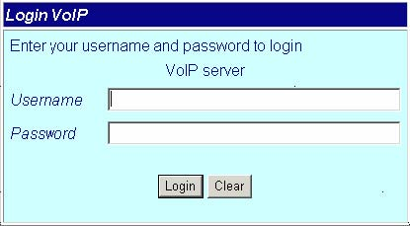

4. On the “Network” node click on the “WAN Settings” subsection.
5. You should now set the desired IP address, subnet mask, Gateway and DNS settings for the device. Click “Submit” to confirm the changes.
6. Now point your browser to the gateway’s new IP.
7. Once the page loads click on the “SIP settings” node and select the “Service Domain” tab;
a. Select “Mobile 1”.from the dropdown.
b. Set the Realm 1 “Active” field to “ON”.
c. Set a “Display Name” to a Friendly name for the line.
d. The “User Name” field should match the Internal Line Number field of the line created for this PSTN line in the 3CX Phone System Management Console.
e. In the “Register Name” and “Register Password” fields enter the ID and Password that you entered for the line in the 3CX Phone System Management Console.
f. Set the “Domain Server” field to the IP Address of the server on which 3CX Phone System is installed.
g. Click the “Submit” button at the bottom of the page.

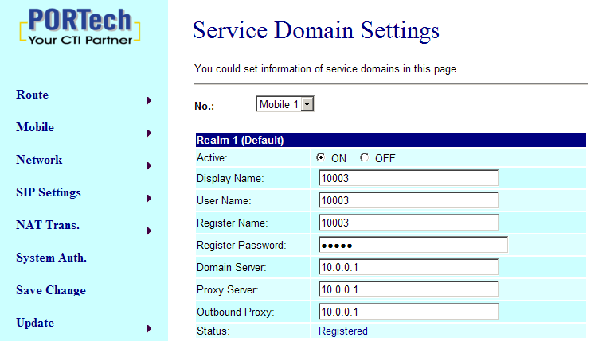

8. Once the page loads click on the “SIP settings” node and select the “Service Domain” tab;
a. Select “Mobile 2”.from the dropdown.
b. Set the Realm 1 “Active” field to “ON”.
c. Set a “Display Name” to a Friendly name for the line.
d. The “User Name” field should match the Internal Line Number field of the line created for this PSTN line in the 3CX Phone System Management Console.
e. In the “Register Name” and “Register Password” fields enter the ID and Password that you entered for the line in the 3CX Phone System Management Console.
f. Set the “Domain Server” field to the IP Address of the server on which 3CX Phone System is installed.
g. Click the “Submit” button at the bottom of the page.
9. Once the page loads click on the “SIP settings” node and select the “Codec Settings” node;
a. Set "Codec Priority 1" to "G711 u-law".
b. Click the “Submit” button at the bottom of the page.
10. Once the page loads click on the “SIP settings” node and select the “SIP responses” node;
a.In the "SIP Responses" section set both options to "ON".
b. Set "Codec Priority 2" to "G711 a-law".
c. Set "Codec Priority 3" to "G729".
d. Set the remaining 'Codec Priority' fields to "Not Used".
e. In the "RTP Packet Length" section set "G.711 and G.729" to "20ms".
f. Click the “Submit” button at the bottom of the page
11. Click on the “Route” node at the top right site of the page. Configure this page as follows:
a. Set the “Mobile To LAN settings” field
b. select from the drop down menu the mobile device you like to configure
Add New
1. Position:= 0
2. CID:=*
3. URL:= “IP Address of the server on which 3CX Phone System is installed “
4. Click the “Add” button at the bottom of the page.
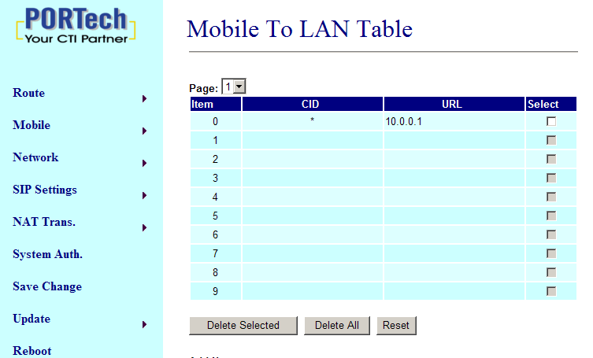
.
12. Click on the “Route” tab at the top right site of the page. Configure this page as follows:
a. Set the “LAN To Mobile settings” field
b. select from the drop down menu the mobile device you like to configure
Add New
1. Position:= 0
2. URL:=*
3. Call Num:= #
4. Click the “Add” button at the bottom of the page.

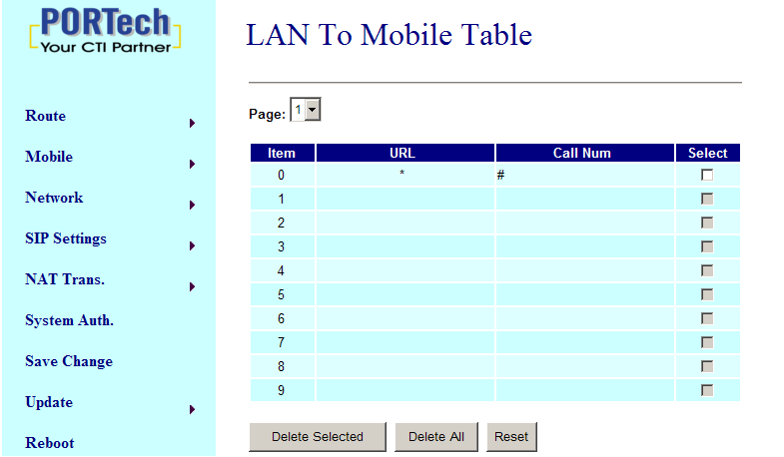

13. Mobile/ Mobile Status
Select from the drop down menu the mobile device you like to configure In this page: Mobile Status, you could get the information of your GSM network and the latest operation.
a. Network Registration: name of telecom carrier, which the SIM card of this device registers at.
b. SIM Card ID: SIM card ID.
c. Signal Quality: place the antenna for higher signal, above 17 is better.
d. Incoming IP: IP address of the last incoming call from Lan.
e. Incoming IP Name: proxy extension name of incoming call from Lan.
f. Outgoing IP: The IP address of the last outgoing call from Lan.
g. Incoming Mob: The caller ID of the last incoming call from Mobile.
h. Outgoing Mob: The destination numbers of the last outgoing call from Mobile.

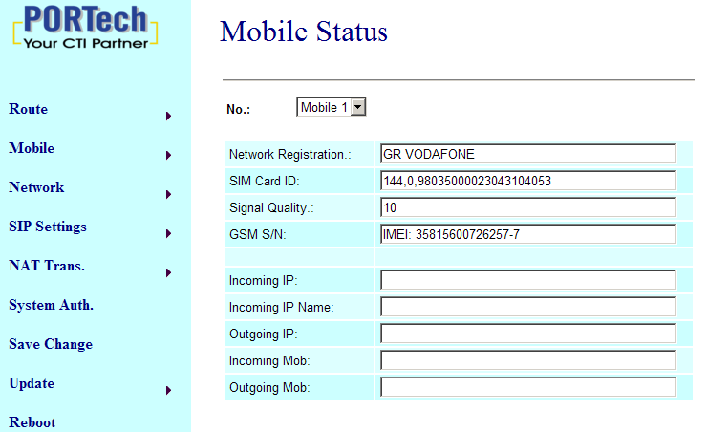
14. Mobile/ Mobile Setting
In this page: Mobile setting, you could adjust the parameter and click on the option to fit your need. You could leave those default value before you had tried the complete operation of this device.
a. VoIP Volume: the sound volume that VoIP passes to Mobile.
b. VoIP Gain: the sound volume that VoIP receives from Mobile.
c. LAN DTMF Gain: the DTMF volume that Lan receives.
d. Mobile In Gain: the DTMF volume that Mobile receives.
Note: you could adjust VoIP Volume and LAN DTMF Gain to fix the DTMF problem in Lan to Mobile operation; you could adjust VoIP Gain and Mobile In Gain to fix the DTMF problem in Mobile to Lan operation.
e. Caller ID: in Mobile to Lan operation, you could select “Clid” to display the incoming call numbers, or “Fix” to display fixed SIP user name on the destination phone.
f. Presentation CLIR: In Lan to Mobile operation, you select “Suppression” to hide the GSM numbers of the device, or “Invocation” to display it on the destination phone.
g. Mobile PIN Code: If you need to unlock pin code via Mobile VoIP, you can click “On” and enter pin code.
h. LAN Answer Mode: This is the LAN answer time while in Lan to Mobile routing.
Answered: when mobile side answers, then connects the call
Alerted: when mobile side rings, then connects the call
Income: when lan side dials out, then connects the call soon
i. Band Type: if your device is Quad band model, you need to choose your GSM frequency.
j. Click "Submit"

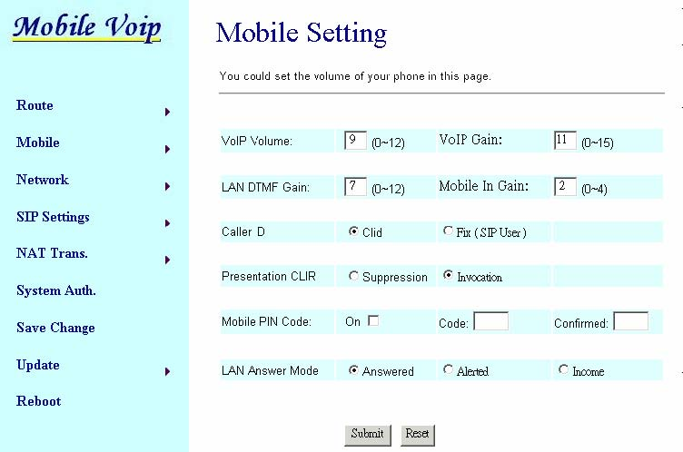

15. Click on the “Save change” node at the top right site of the page, then click on the "Save" button.
After the gateway has restarted, switch to the 3CX Phone System Management Console, and click on Phone System -> ‘Line Status’ (This is the default page). In the section ‘External Lines’, the PSTN lines connected to the VoIP Gateway should be listed with a green status light.

